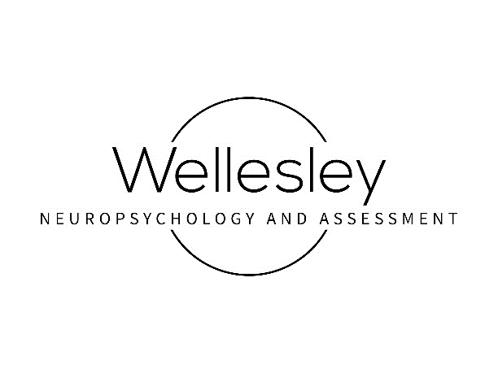
EVAULATION CONSENT AGREEMENT
Thank you for choosing Wellesley Neuropsychology and Assessment, LLC for your care.
This Evaluation Consent Agreement (Agreement) contains important information about our professional services and business policies. It also contains summary information about the Health Insurance Portability and Accountability Act (HIPAA), a federal law that provides privacy protections and patient rights about the use and disclosure of your Protected Health Information (PHI) for the purposes of treatment, payment, and health care operations. Although these documents are long and sometimes complex, it is very important that you understand them. When you sign this Agreement, it will also represent a legal agreement between us. We can discuss any questions you may have when you sign them or at any time in the future. You may revoke this Agreement in writing at any time by sending a letter to Wellesley Neuropsychology and Assessment, LLC, 892 Worcester Street, Suite 210, Wellesley, MA 02482 or via FAX at 781-383-7874. That revocation will be binding on Wellesley Neuropsychology and Assessment LLC unless we have taken action in reliance on it; if there are obligations imposed on Wellesley Neuropsychology and Assessment LLC by your health insurer in order to process or substantiate claims made under your policy; or if you have not satisfied any financial obligations you have incurred.
Nature and Purpose: Wellesley Neuropsychology and Assessment LLC offers two types of overall evaluations. Here is a summary:
- A neuropsychological evaluation is a comprehensive assessment of an individual’s overall brain functioning through examination of cognitive domains including intellectual functioning, language, memory, non-verbal skills, and executive skills, including attention, inhibition, working memory, processing speed, planning and reasoning, and organization. In addition to the 1:1 work investigating a patient’s neurocognitive abilities, neuropsychological evaluations also include completion of rating forms in order to gain a better sense of the patient’s day-to-day functioning, as well as interviews that may cover topics such as medical history, general background, academics, and social functioning. The purpose of the evaluation is to provide insight into the functioning of the patient, make a diagnosis when appropriate, and provide recommendations. Wellesley Neuropsychology and Assessment LLC will use information gathered to prepare a report, which will be distributed to the “client” (the payer of the evaluation” and, if applicable, the patient’s legal guardian(s)). As the evaluation is tailored to the patient, after discussion, it may be decided a focused or specialized evaluation will best fit the patient’s needs.
- A psychological evaluation functions similarly to a neuropsychological evaluation, but instead of examination of cognitive domains, an individual’s psychological and behavioral functioning is the focus of the evaluation. Rating forms are utilized to provide information on day-to-day functioning. Interviews are also included; general background, social functioning, behavioral functioning, and medical history, are some of the topics covered. The result of the evaluation is to gain insight into the functioning of the individual, make a diagnosis when appropriate, and provide recommendations.
Report: For either type of evaluation, Wellesley Neuropsychology and Assessment LLC will use information gathered to prepare a report and then distribute the report to the “client” (the payer of the evaluation) and the child’s parent/legal guardian. As the legal guardian, you may decide to release the report to other parties.
On either type of evaluation, each patient is asked to work to the best of their ability. Their degree of effort might be assessed as part of the evaluation. Failure to provide their best effort may result in invalid results. Similarly, during the interview it is important to provide the most accurate information possible.
Foreseeable Risks, Discomforts, and Benefits: For some individuals, neuropsychological or psychological evaluations can cause fatigue, frustration, and/or anxiousness. Attempts will be made to help minimize such impact. If anything interferes with your or your child’s ability to participate fully in the evaluation process, please tell us so that we can try to correct or control for the situation as best as possible. There is no guarantee of outcome from this evaluation. The hope is to provide you additional insight into the functioning of you or your child.
Procedures:
Consultation: A phone consultation will occur during which the individualized plan for the patient will be made. This consultation may take place in one or more sessions.
Evaluation: Depending on the type of evaluation, you might be asked to sign additional consents for us to speak with outside parties and you may be asked to help have teacher rating forms completed.
Report: Once all the testing and interviews have been completed (and if your evaluation includes outside rating forms, once these are also received), Wellesley Neuropsychology and Assessment LLC will complete a report discussing the findings, provide a diagnosis, if appropriate, and provide recommendations (unless otherwise stated such as in the case of school admissions testing). If there is a sensitive date by which the report needs to be generated (e.g., for a school meeting), any records to be included in the evaluation must be received two weeks prior to this date. A feedback session will be offered to the family to review the report. Also, at the time of feedback you can advise / notify Wellesley Neuropsychology and Assessment LLC if there are any additional parties you would like to receive a copy of your report.
Additional Services: Should any additional services be desired, they can be arranged at the onset of the evaluation or at the time of feedback for an additional fee.
Fees: There is an initial free consultation for every new patient evaluation (up to 15-minutes). At that time, an individualized plan will be made and a fee will be discussed. The fee is due at the first appointment or in 2 installments (in the case of Independent Educational Evaluations being funded by the school district, the fee is due within 2 weeks of the receipt of the report). There is a $250 fee for a missed appointment for testing. Due to the constraints placed upon our services by insurance companies, we are unable to accept any insurance plans at this time. We are happy to provide you with an invoice for you to file a claim with your insurance company.
Please note that Wellesley Neuropsychology and Assessment would be considered an out of network provider and most insurances do not cover academic or ADHD testing. You are responsible for the entire cost of the service; your insurance may or may not choose to reimburse you for some or the entire fee.
Payment is by cash, check or credit card. There will be a $50.00 fee assessed for all returned checks. Fees are subject to change without notice.
Limits of Confidentiality: Information obtained during the evaluation is confidential and can ordinarily be released only with your written permission. There are some special circumstances that can limit confidentiality including: (1) a statement indicating harm or abuse of children or vulnerable adults (2) a statement of intent to harm oneself or others, (3) issuance of a subpoena from a court of law, (4) in natural disasters whereby protected records may become exposed, or (5) when otherwise required by law. Clinicians occasionally consult with other health and mental health professionals on cases, if so, they make every effort to avoid revealing the patient’s identity; such other professionals are legally bound to keep the information confidential.
Treatment of Minors: Treatment of patients under the age of 18 will be provided only with the consent of the parent or legal guardian. In cases of divorce, a copy of the custody agreement must be provided in advance. Most custody decrees entitle the non-custodial parent to access the health record without consent from the custodial parent.
By signing this Evaluation Consent Agreement, you acknowledge that you are the patient’s guardian (as established by the state or the divorce decree).
Patients under the age of 18 (who are not emancipated) and their parents/legal guardian should be aware that the law may allow parents to examine their child’s treatment records. Before giving a parent/legal guardian any information, we will discuss the matter with the child, if possible, and do our best to handle any objections he/she/they may have. If the patient is a minor, he/she/they will not be seen without his/her/their parent/legal guardian present.
Signature: Your signature indicates that you have received this Evaluation Consent Agreement (3 pages total), and have read, understood, and agree with the nature and purpose of the evaluation, and to each of the points listed above. You have also received our Notice of Privacy Practice your HIPAA rights (such notice is also available on our website or upon request). Additionally, you had an opportunity to clarify any questions and discuss any points of concern before signing.
Who can provide consent: Massachusetts law authorizes the parent(s) or legal guardian to consent for most medical decisions including mental health assessments and treatment on behalf of the minor. If the parents are married and not separated, either parent acting alone may consent to the mental health treatment for the minor. However, for parents who are divorced it is critical that either both parents sign providing consent or that Wellesley Neuropsychology and Assessment LLC receives a copy of the custody order indicating which parent has legal medical decision-making authority prior to the evaluation. If there is joint legal custody, either parent acting alone may consent to mental health treatment, unless the custody order has language to the contrary.
CONSENT FOR EVALUATION

_______________________________________
Patient Name (full name)

_______________________________________ _________________________________
Signature of Patient Date
or [ ] if Patient is a minor of the Patient’s Parent/Legal Guardian

